

**INSTALLATION MANUAL**

### **Table of Contents**

### **Applicable Version**………………..…....……………………………….……………………….1

### **Installation**....………………………….……….……………………………………………………1

### **Configuring Ingenico**………………..……………………………………………………………4

### **Applicable versions**

|  |  |
| --- | --- |
| **Applications** | **Versions** |
| PHP | 5.6 to 7.4.x |
| Opencart | 3x |

### **Installation & Upgrade**

Please follow the given steps to install and run the Ingenico Payment Gateway module

1. Log in to admin panel

2. Under navigation go to Extension->installer

3. Unzip the downloaded package and select the ingenico package with extension .ocmod.zip and click on upload

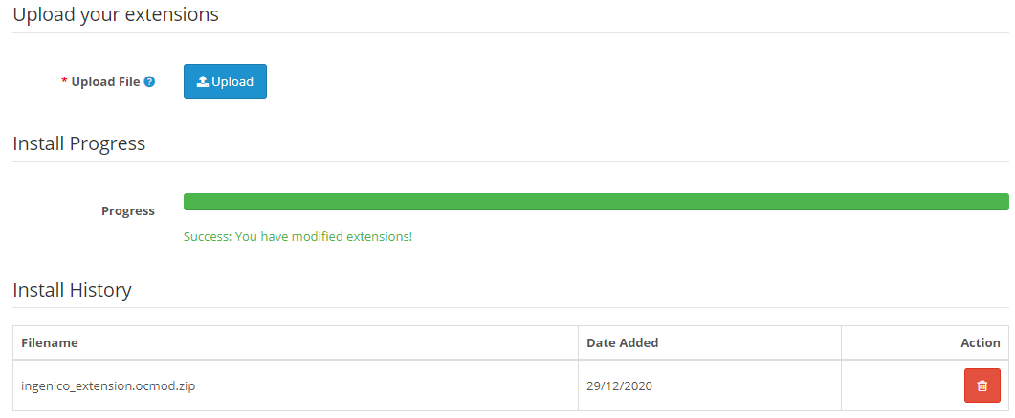

4. After successful installation go to Extension->Modifications

5. You will see ingenico package, then click on refresh

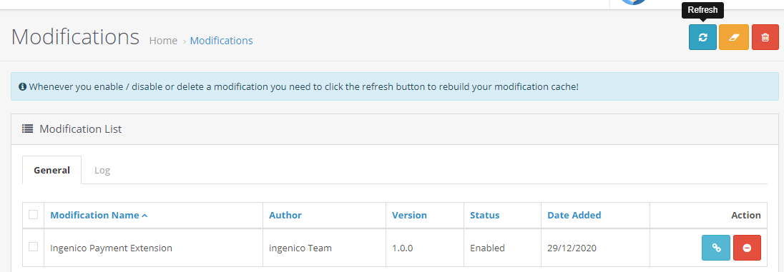

6. Then go to Extension->Extensions choose type as payments

7. You will see ingenico ,install it

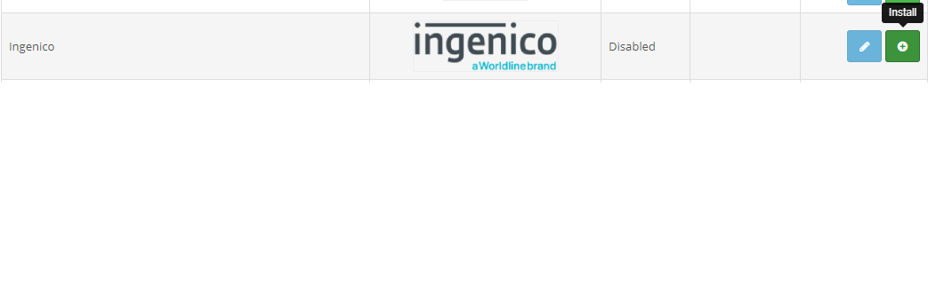

8. Then under Navigations go to System->Users->User Groups

9. Edit administrator,

Under Access Permission select extension/payment/reconciliation and extension/payment/verification.

Under Modify Permission select extension/payment/reconciliation and extension/payment/verification

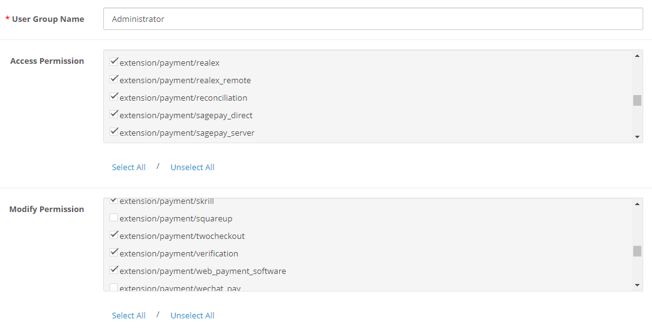

10. Click on save

**Update Plugin**

1. Under Navigation Go to Extensions->Extensions select type as payments and Uninstall Ingenico

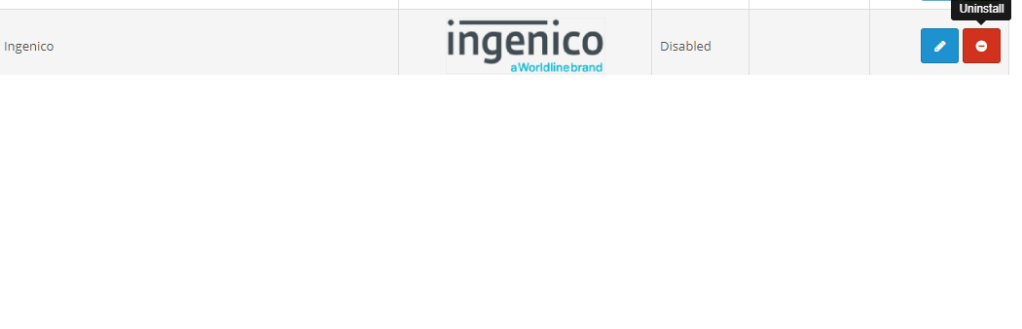

2. Then go to Extensions->Installer and Uninstall Ingenico

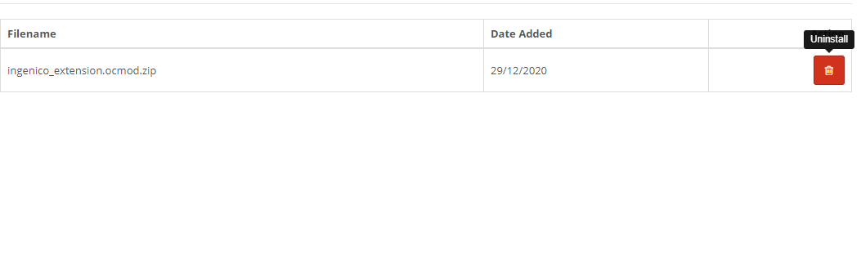

3. Then install the New Ingenico package again as mentioned above

### **Configuring Ingenico**

1. Go-to go to Extension->Extensions choose type as payments
2. Scroll down. You will see ingenico, Edit it
3. Configure it as below:

|  |  |
| --- | --- |
| **Column Name** | **Description** |
| Status | “Enable” to enable and use, else “Disable” to disable ingenico |
| Merchant Code | Enter Merchant Code |
| Salt | Enter Salt. |
| Payment Type | For Test mode Select ‘Test’ and for Live mode select ‘Live’ |
| Merchant Scheme Code | Enter Scheme Code |

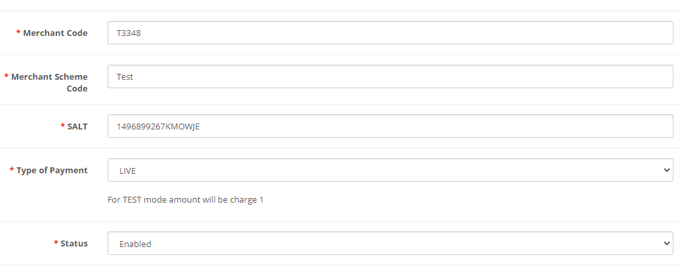

1. Now click on “Save Changes” on top- right corner.
2. Ingenico Payment Gateway is now configured & ready to use.

**Advanced Configuration**

There are also some advanced configuration options you may consider as shown below:

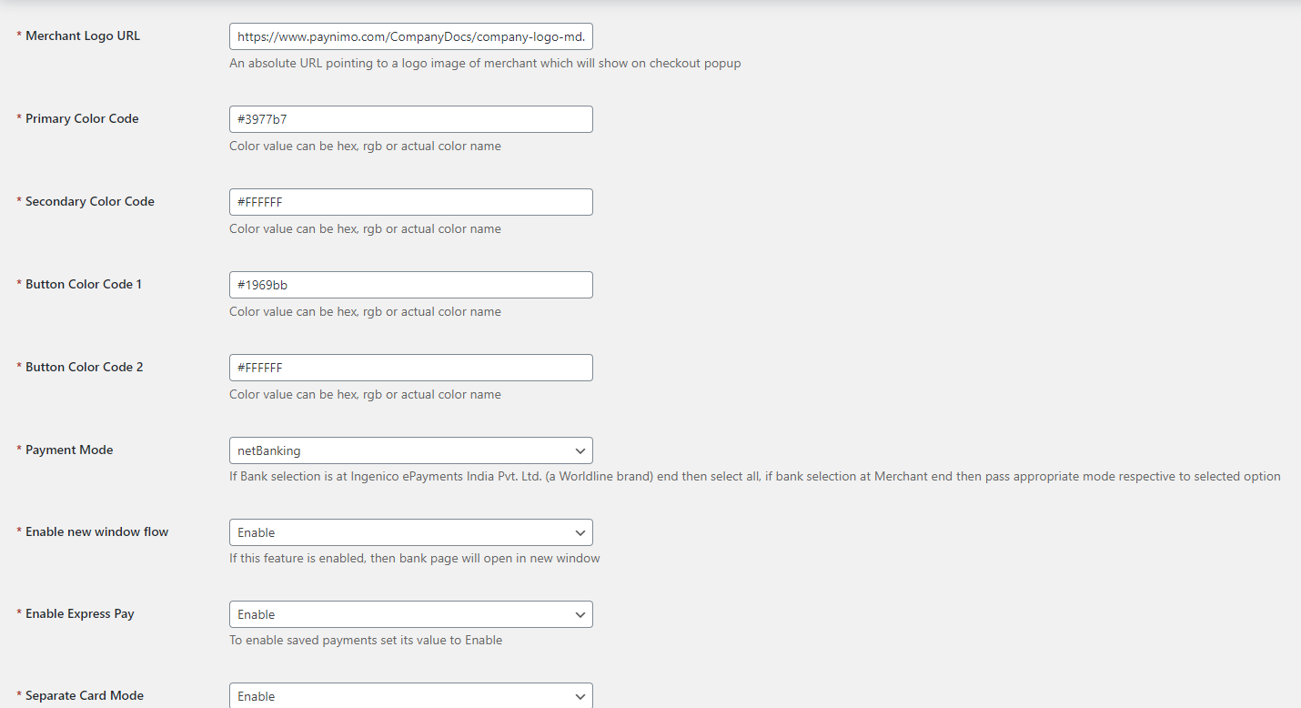

## **Features List**

### **Dual verification of response**

We are validating responses with a hash value and call again Payment Gateway for dual verification from the payment gateway before updating to the order status.

### **Reconciliation**

Merchants can update the pending status of the order automatically if the payments are successful. This page can be found under Left Admin menu Sales- > Reconciliation

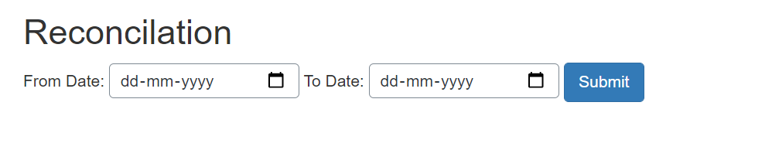

### **Logs request and response**

Daily new file creates for the logs request and response from the server for future reference.

### **S2S Verification**

If we do not receive any response from the payment gateway then after 30 mins, we will get a response from the server and based on the response it will update order status.

To configure S2S URL, contact prod team.

S2S url format : hostname/index.php?[route=extension/payment/ingenico/s2sverification](http://localhost/op3032demo/index.php?route=extension/payment/ingenico/s2sverification&msg=0300%7Csuccess%7CNA%7C506214%7C470%7C1325863698%7C106.00%7C%7Bitc:%7D%7Bcustname:Russel)&msg=

S2S url example: [http://example.com](http://localhost/magento_mirror/index.php/ingenico/payment/s2sverification)[/index.php?route=extension/payment/ingenico/s2sverification&msg=](http://localhost/op3032demo/index.php?route=extension/payment/ingenico/s2sverification&msg=0300%7Csuccess%7CNA%7C506214%7C470%7C1325863698%7C106.00%7C%7Bitc:%7D%7Bcustname:Russel)

### **MCG**

It supports the multi currency like USD, GBP, SGD and a lot more.

### **Offline Verification**

Merchants can verify the status of their payment by using the Payment Verification page. The payment verification page can be found under Left Admin menu Sales-> Offline Verification

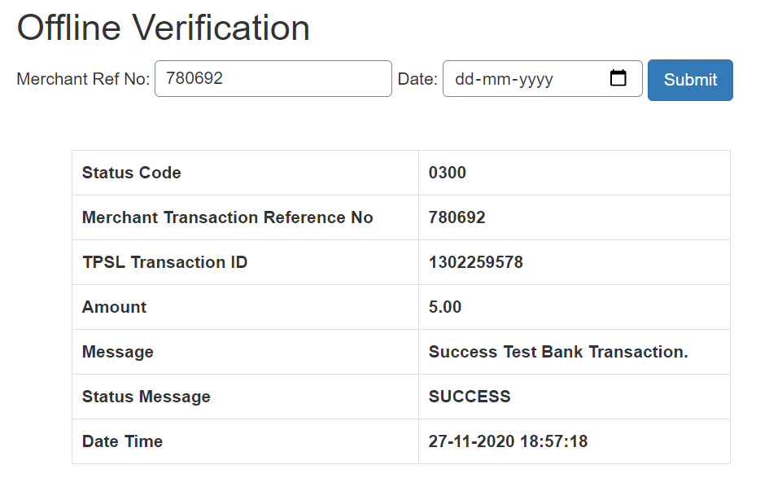

### **Refund**

Merchants should be able to process the refund online for the order whose payment has been done via Ingenico.

To refund an order select the particular order you want to refund and click on View scroll down, Under order history select Ingenico

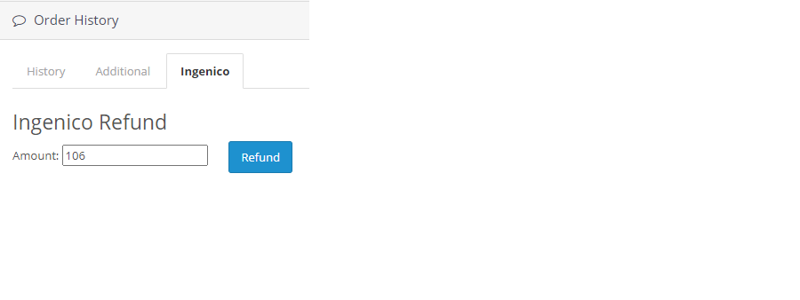

### **Embed Payment Gateway**

After enabling this setting, payment gateway displays like embedded on the page instead of pop-up so user experience would be good.

## **Documentation link**

[**https://www.tecprocesssolution.com/proto/p2m/client/salt-based-documentation.htm#online**](https://www.tecprocesssolution.com/proto/p2m/client/salt-based-documentation.htm#online)